[1]

Training and Placement Portal

Hiba DilavarShah Rajguru1, Saurabh Kolambkar2, Omkar Shelar3

Information Technology

A.P Shah Institution of Technology

Thane

Email: [Rajgurufahinds2215@gmail.com1](mailto:Rajgurufahinds2215@gmail.com1), [kolambkarsaurabh4@gmail.com2](mailto:kolambkarsaurabh4@gmail.com2), [omkar.shelar41@gmail.com3](mailto:omkar.shelar41@gmail.com3)

*Abstract*— This portal focuses on automation of conventional training and placement department in the college. This portal can be used as an application for the Training & Placement Officers in the college. This also automates activities of training and placement cell providing opportunities to the student community to use collective processes to increase selection ratio and eases out process of creation of management information automatically. It focuses on the automation of the placement cell. Authorizing the resumes, communicating about the various job openings to the student community, managing the corporate relationship for inviting them for the placements in the college. Providing Student login helping them to update their personal and educational information in a form which will be added to the database. It provides the module like Student (Current Student), Administrator (TPO), Faculty (Departmental Staff). It manages Placement process of each Job posting individually. Manage Company Profiles, Manage Job Postings, Authenticate and activate the student profiles, Send Notifications to students, create list of students as per company criteria, providing the list of shortlisted students as per eligibility, manage student profile, set preferences for student eligibility criteria for placement, Time & Role Based Secured Access to users It reduces the manual work and consumes less paperwork to reduce the time. It can assist the TPO to concentrate on their activities rather than concentrating on record keeping. Thus, it will help college in better utilization of time and human resources. TPO can maintain computerized records without redundant entries. Front end of the system is developed with the help of CSS, Bootstrap, and HTML. Backend of this portal will be managed with the help of PHP. Database management of this system will be done with the help of MYSQL database.

# INTRODUCTION

In today’s world everyone is travelling for jobs after Completion of their graduation. It has become need for each and every student, but for that they need to travel worldwide in searching of jobs. For simplicity of this whole hectic procedures we had proposed Training and Placement Portal because of earlier system is totally done manually by maintaining records, time consuming and very difficult to maintain coordination between student and companies.

This project is been developed to maintain the details of student information, trace the details of the student from the Student Handbook and also maintain the information about the company availability. Through this portal, the student may know all the details of the events which will be provided by the Training and Placement oﬃcer, the student can view the information of the upcoming company and dates of the upcoming drives. In the same way in this project one more user is involved he/she is most important person who is able to mainly control all the information called Administrator which will be the Training and Placement oﬃcer of our college. He can do updates about any events or company information. He maintains a database that will present the status of the student who will be performing the placement processes (aptitude, G.D, Interviews). Another user in this project will be the HOD and Staﬀ of every department in our college who will be notiﬁed about every activity their student performs.

The placement cell calls the companies to select their students for jobs via the campus interview. It allows the companies to view the student’s resumes in a selective manner. They can filter the student’s profile as per their requirement. The job details of the placed students will be provided by the administrator. The administrator plays an important role in our project. Our project provides the facility of maintaining the details of the students and gets the requested list of candidates for the company who would like to recruit the students based on given query.

# traditional training and placement process in college

The current existing system is not computerized. All transactions in the system are done manually such as maintaining records. To make this laborious job simple, the we have to computerize the system. The management that have been carrying out this job manually makes the job more complicated and tedious most of the times. For example, in the earlier system placement oﬃcer has to collect student details for placements. Approving those student details takes lot of time. Placement oﬃcer and students have to consult each other directly if any information is required. If any new company arrives for placements, the placement oﬃcer and his staﬀ have to search the student details and they have to search eligible candidates for that particular company placement. Here search for eligible candidates takes lots of time.

## Circulating process.

The placement officer circulates every new company and its details by chatting application i.e Whatsapp or by posting it on the college notice board.

## Selecting the eligible Students.

The placement officer has to assign coordinators to maintain a record for particular students under them and validates of the details are correct or not, this process contains a lot of time and efforts and then sort the student according to companies’ criteria.

## Poor Communication

Poor communication between students and placement oﬃcer, so here intimating about new placements is a hard task. Candidate may not get required information if concerned Training and Placement is not available i.e busy with ongoing task. Students may not know about company details.

# proposed system

# The proposed system is fully computerized, which removes all the drawbacks of existing system. Proposed system is an online application that can be accessed throughout the organization and outside as well with proper log-in provided. Students who log-in should be able to upload their information in the Student Handbook. When the user logged into his respective page, he will be able to see the upcoming events and can register. The academic details of the students are approved by the administrator. All the users have some common services like changing password, updating details, searching for details, checking the company details, and reading the material uploaded by admin if the user is a student or any Staﬀ. Administrator activities include adding events, verify the student information and maintain overall information ﬂow. He can upload materials, search for student details, and has the right to approve the students’ academic information. HOD can view student status in the placement process.

## Registration.

The users in this website (**Admin** [Placement Officer], **Faculty** [Teachers and HOD] and **Students**) will be provide with their login id’s and passwords. Thus, an account is created in the website which shows a profile of the individual’s login. Students will update their information, and will be notified by upcoming companies.

## Generating Resumes.

The resumes of the student will generate automatically from the information uploaded in the **Student Handbook** according to the standard Resume Format.

## Sorting the Students.

The bubble sorting algorithm will be implemented to sort the students according to the criteria of the company.

## Notifying the Students.

The students will be notified about the events happening related to the placement in the college. The selected and the non-selected applicants will be notified through the website along with SMS or EMAIL.

## Selecting the right Student

By conducting different placement steps through objective, fair, accurate and reliable assessment the potentiality of the Students and likely job performance are understood. Thus, the right people for the job are selected through periodical assessment which increases the efficiency the company.

# Diagrams

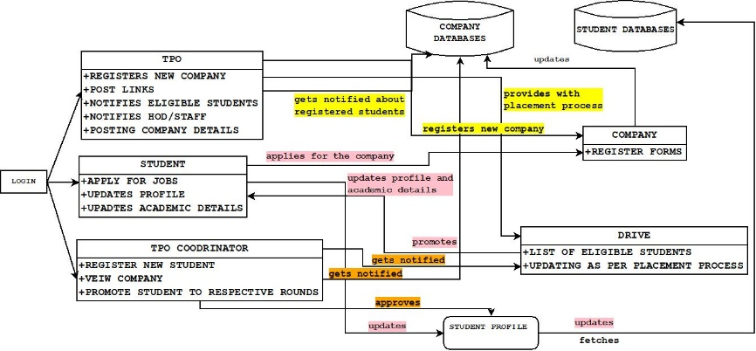

**Fig1: Working Diagram**

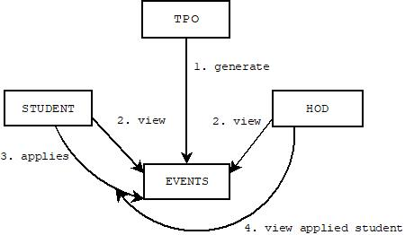

**Fig2: Home Page**

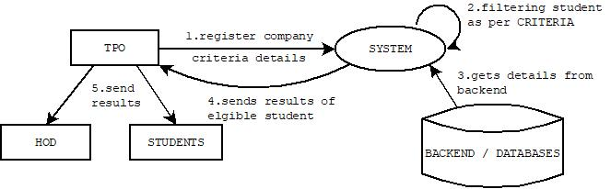

**Fig3: Sorting Students**

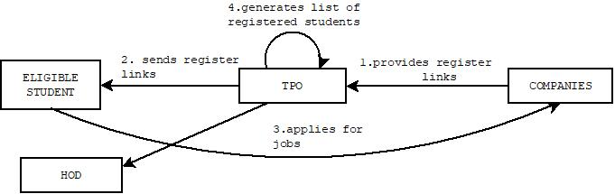

**Fig4: Application by Eligible students**

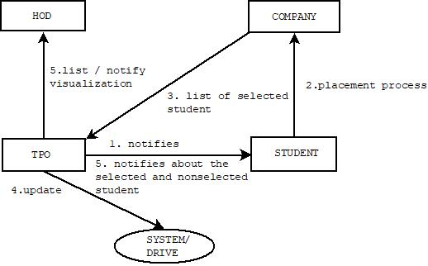

**Fig5: Updating Drives by TPO**

# Conclusion

This Project is designed to assist in strategic planning, and will help you ensure that our college is equipped with the right level of information and details for future goals. Also, for those busy staﬀs who are always on the go, our systems can be remotely accessed, which will allow us to manage our workforce anytime, at all times. This system will ultimately allow us to manage our time and eﬀort put in these placement activities in an eﬀective manner thus having smooth functioning. This will be a user friendly, error free, secure and fast management system.

Acknowledgment

It is our advantage to acknowledge with deep sense of gratitude to our project guide **Prof. Rujata Chaudhari**, our Co- guide **Prof. Anagha Aher** and our H.O.D **Prof. Kiran Deshmukh** whose supervision, inspiration and valuable discussion has helped us to complete our project. Their guidance proved to be the most valuable to overcome all the complications in the fulfillment of this mega project on “**Training and Placement Portal**”. We are thankful to Principal **Mr. Uttaham Kolekar** for direct or indirect help in the completion of this project. Last but not least, this acknowledgement would be incomplete without rendering our sincere gratitude to all those who have helped us in the completion of this project.

References

1.